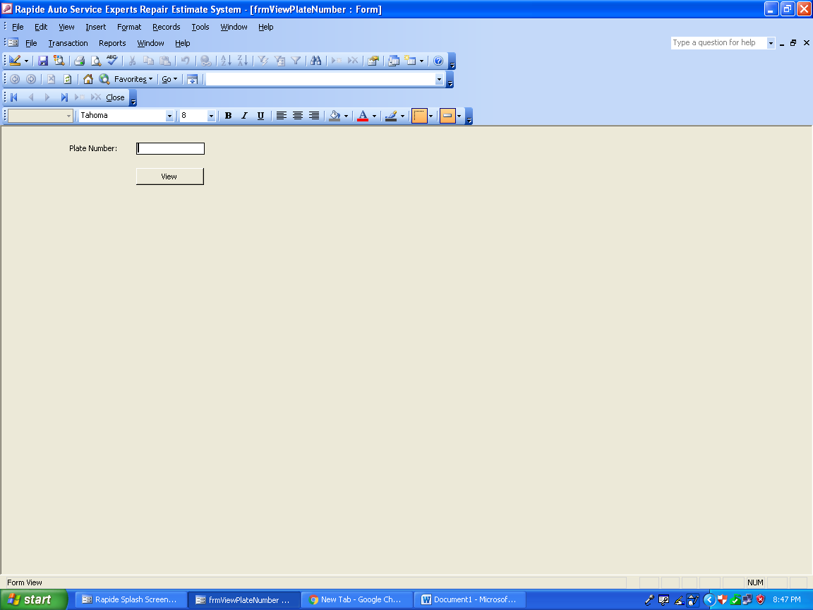

VIEW CUSTOMER PAGE

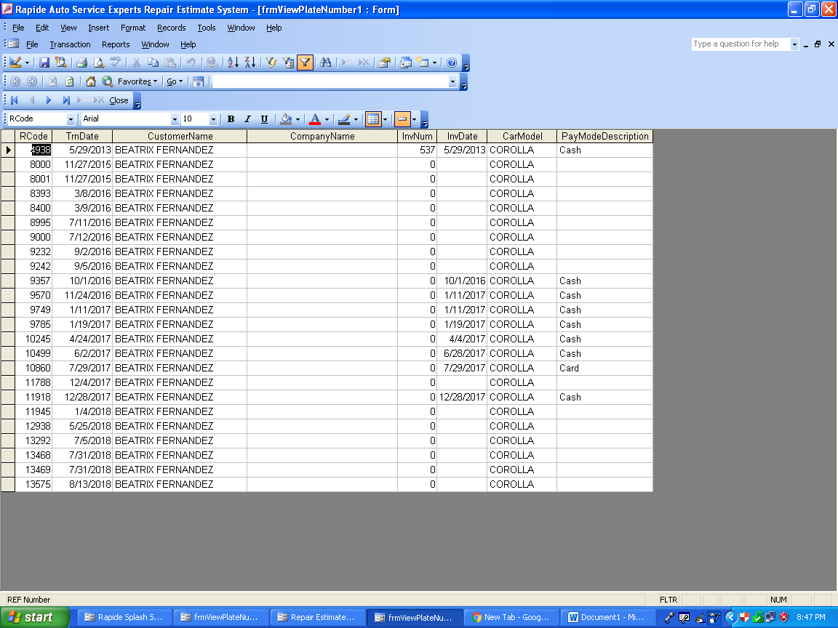

ALL ESTIMATE LIST FOR ONE PLATE NUMBER

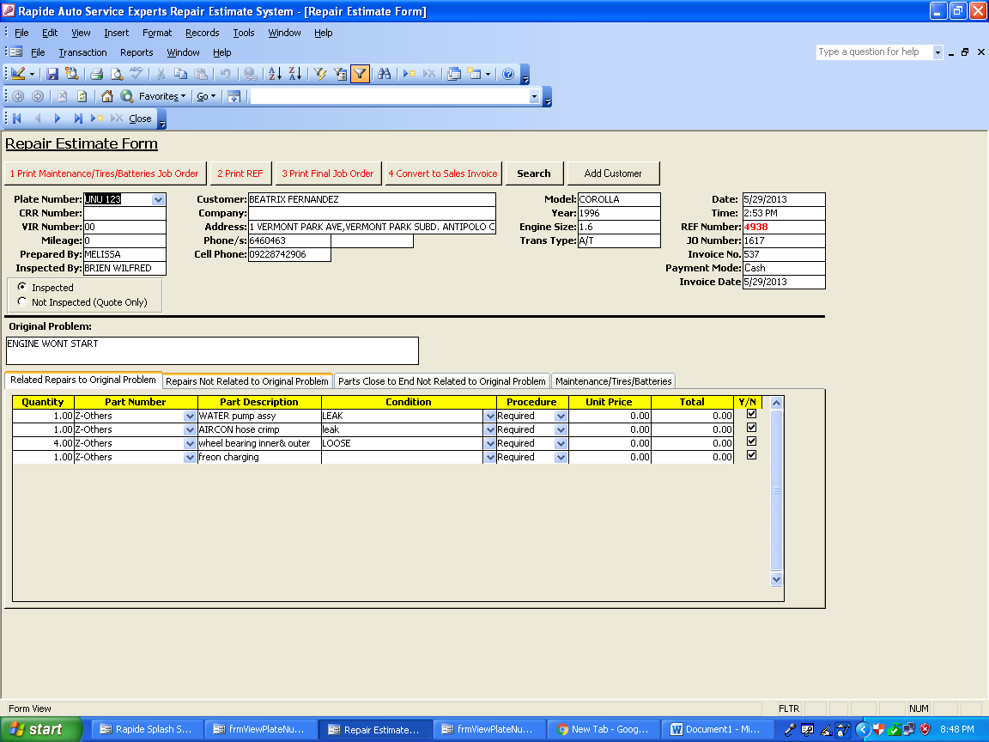

ESTIMATE FORM

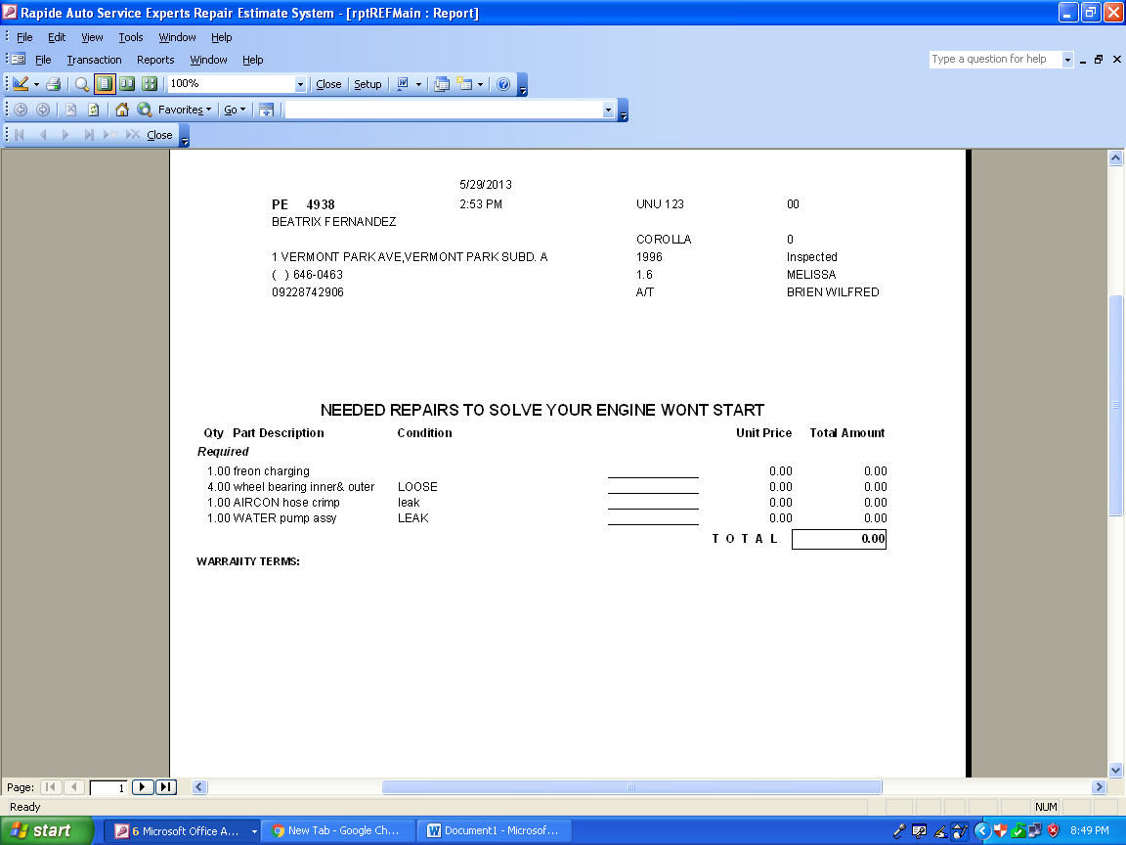

ESTIMATE PRINT

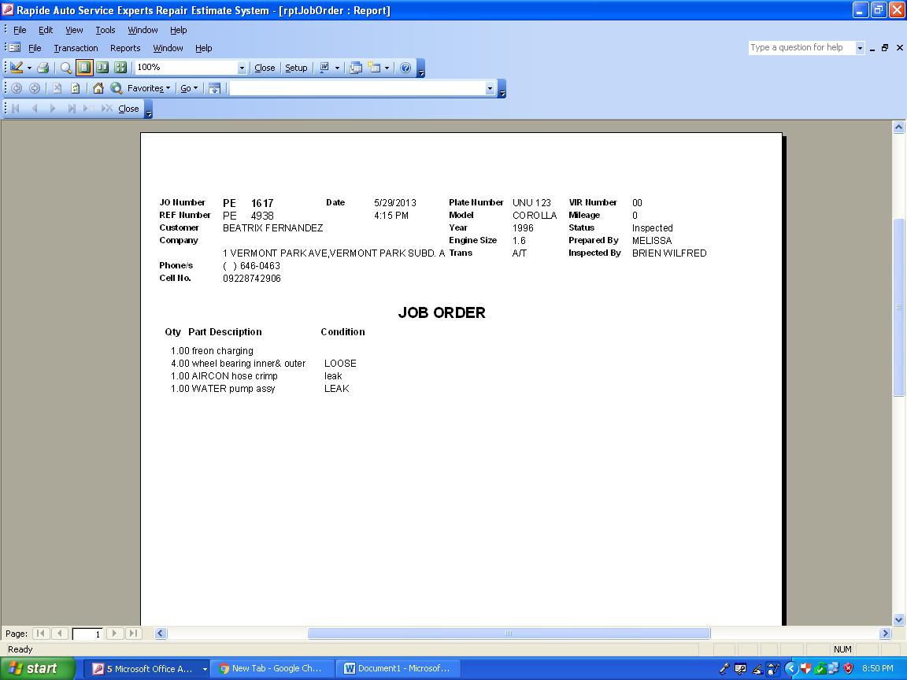

JOB ORDER PRINT

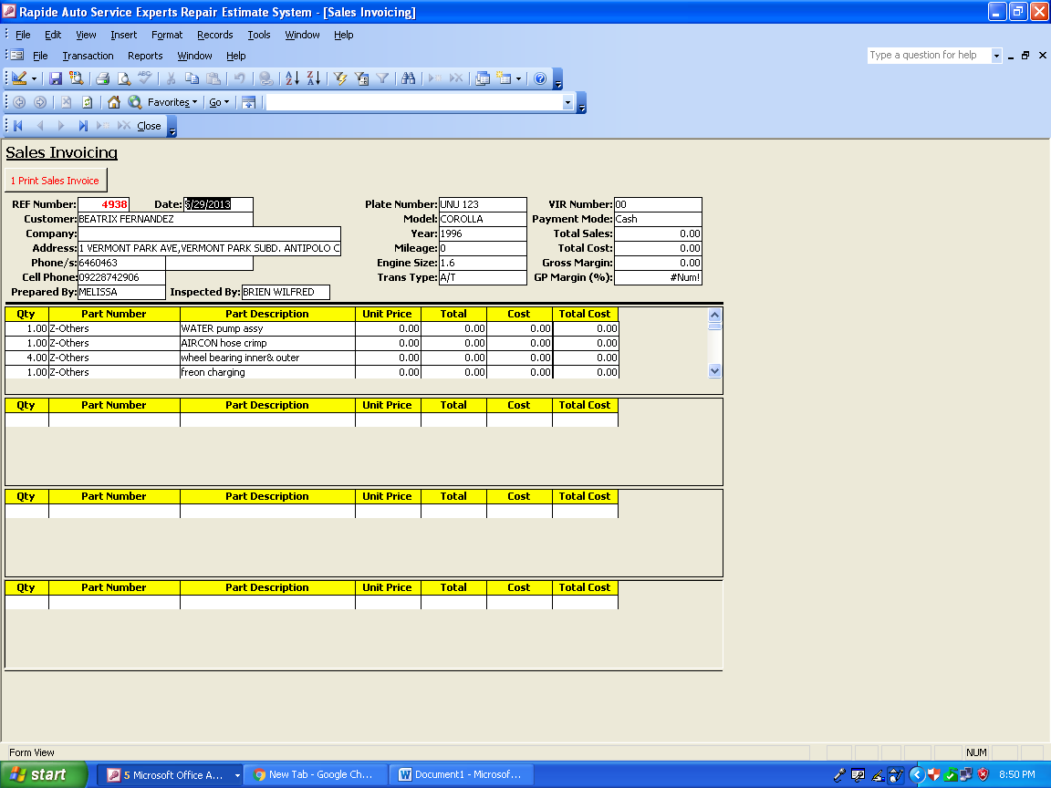

SALES INVOICING FORM

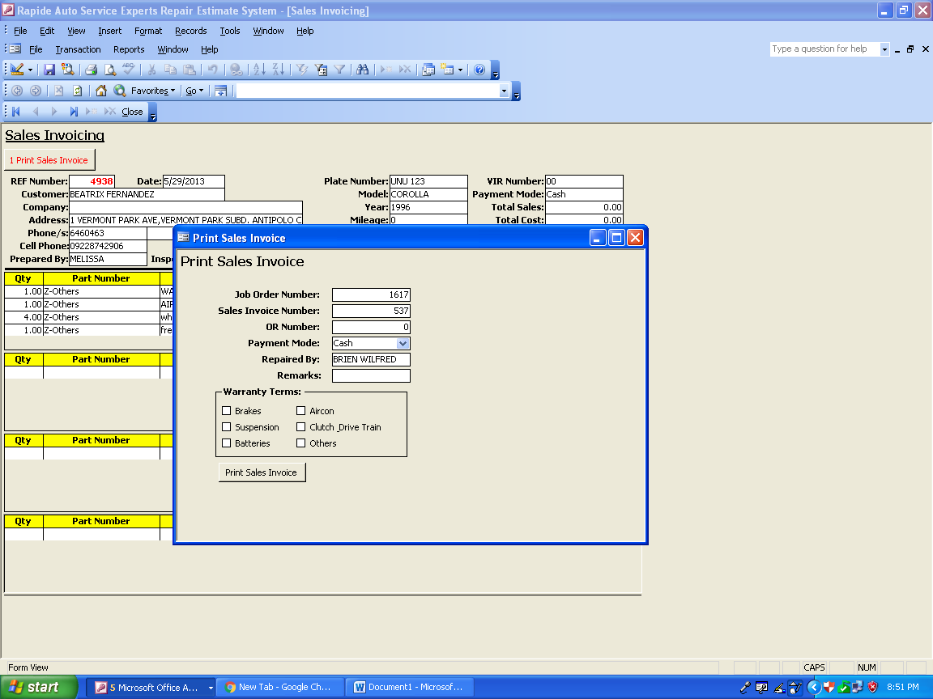

ADDITIONAL INFO FOR SALES INVOICING BEFORE PRINTING

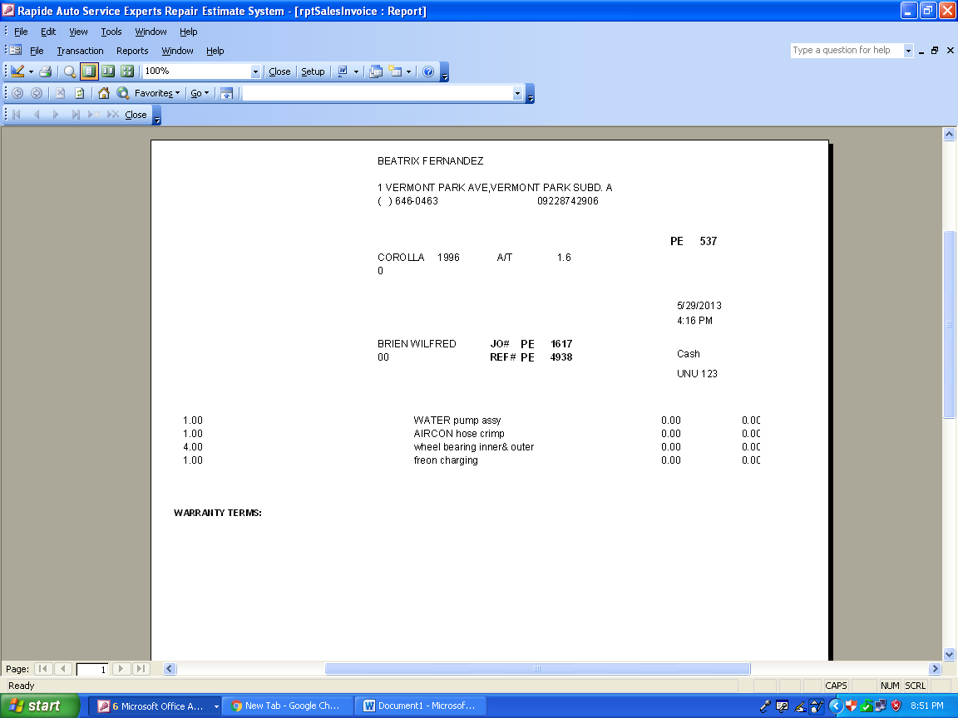

SALES INVOICE PRINT

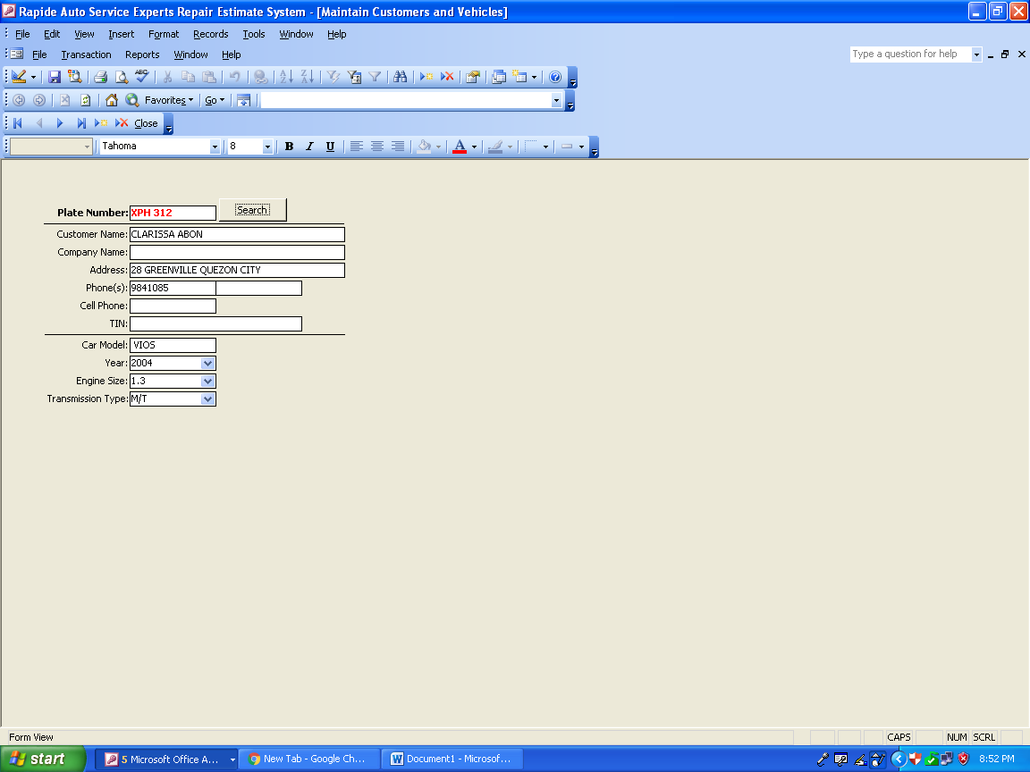

ADDING CUSTOMER PAGE

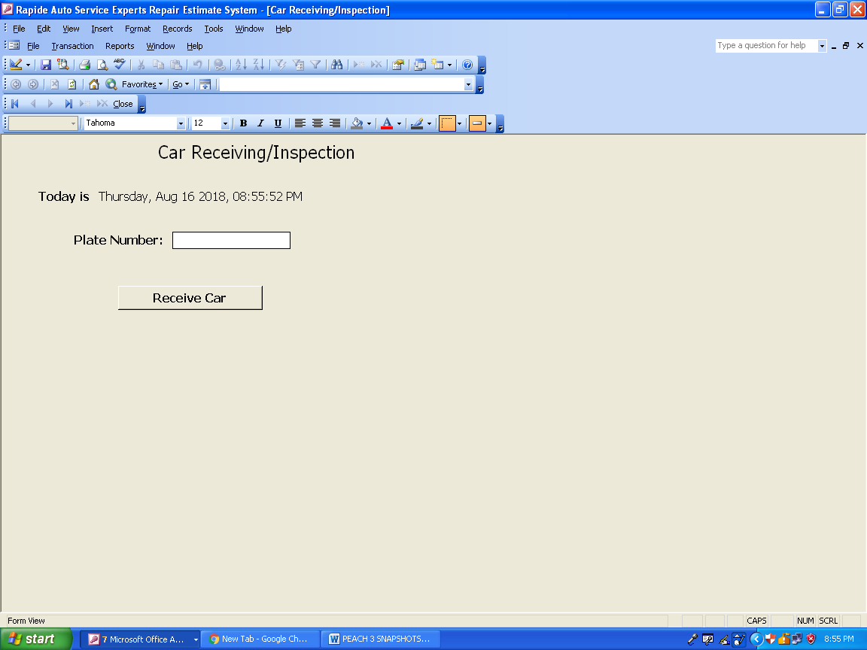

RECEIVING CAR PAGE

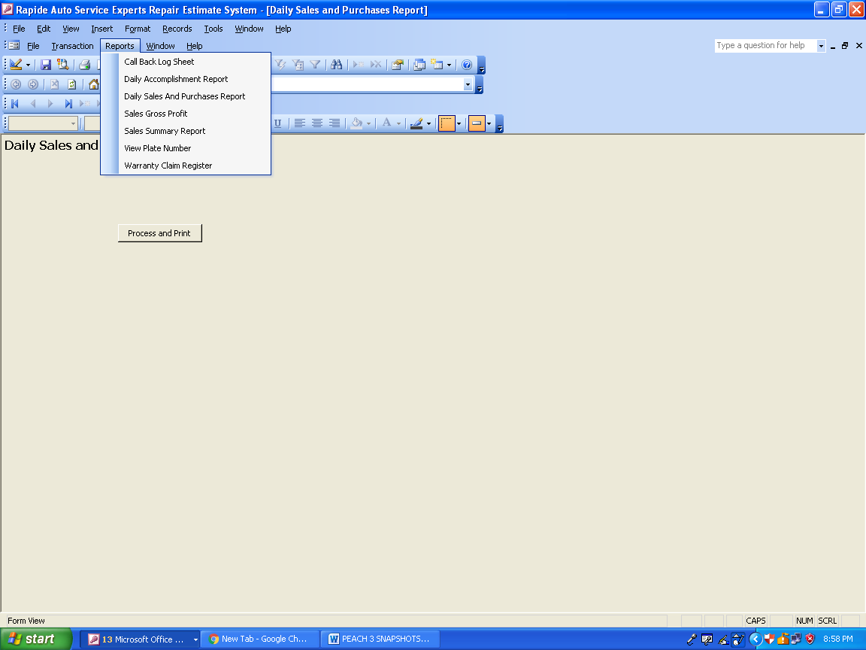

DROP DOWN MENU 2

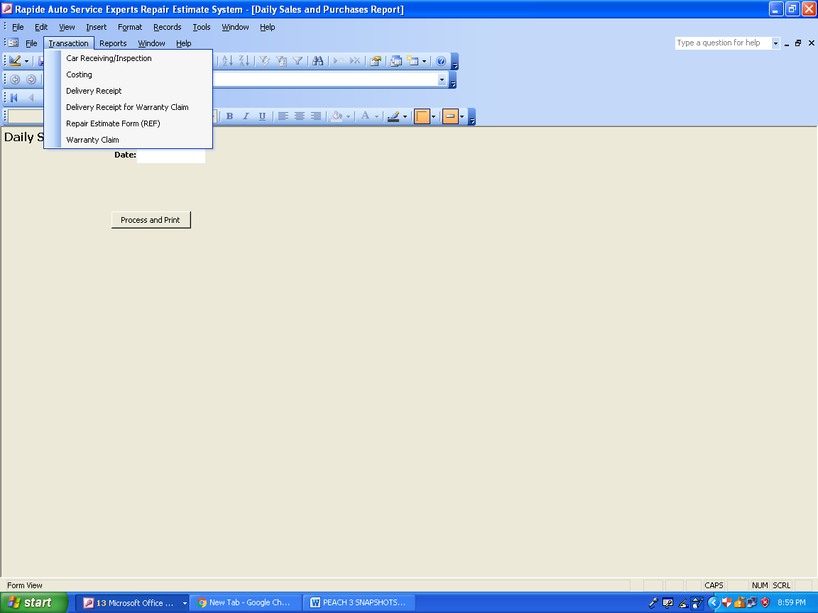

DROP DOWN MENU 1